

DAVID LEWIS EDUCATION
Application Form

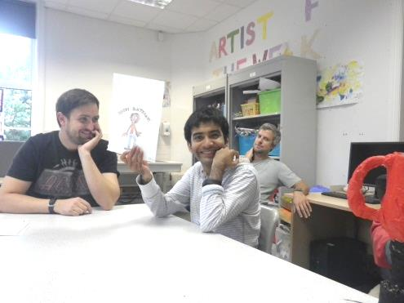
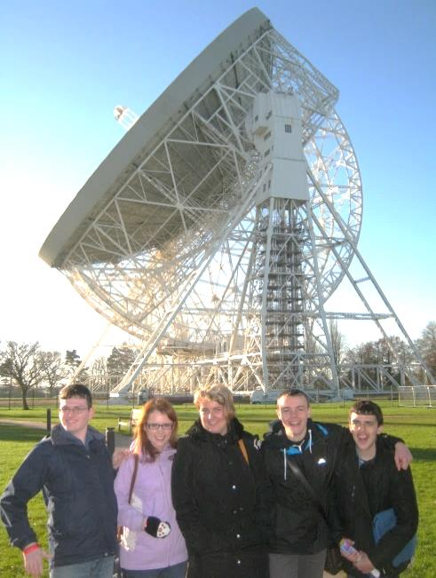
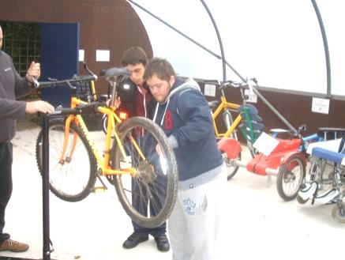

All information included on and accompanying this application form will be treated as private and confidential

Please return to the Admissions Team, at:

David Lewis College, Mill Lane, Warford, Nr Alderley Edge, Cheshire SK9 7UD

Education.admissions@davidlewis.org.uk

Applicant Name: _____________________








Completed By
Parent |  | ☐
Carer |  | ☐
Other (give details)
Your Name

Which month/year are they applying for?
Which provision are they applying for? (Please tick below)
David Lewis School
David Lewis College
What type of placement are they applying for?
Day | ☐
38 week term time residential | ☐
52 week residential | ☐
Are there any requirements for out of term time respite provision? (Residential term time students only) If so, please indicate how much respite is required.

Young person’s details
Forename(s)
Surname
Address (line 1)
Address (line 2)
City/Town/Village
County and Post Code
Email
Telephone
Date of Birth
National Insurance Number
National Health Number
Gender | Male | ☐ | Female | ☐

Ethnicity
White
English / Welsh / Scottish / Northern Island / British | ☐
Irish | ☐
Any other white background | ☐
Mixed / Multiple ethnic groups
White and Black Caribbean | ☐
White and Black African | ☐
White and Asian | ☐
Any other mixed / multiple ethnic backgrounds | ☐
Asian / Asian British
Indian | ☐
Pakistani | ☐
Bangladeshi | ☐
Chinese | ☐
Any other Asian background | ☐
Black / African / Caribbean / Black British
African | ☐
Caribbean | ☐
Any other Black / African / Caribbean / Black British background | ☐
Other ethnic group
Arab | ☐
Other | ☐

Parent/Guardian Details 1
Title | Mr | ☐ | Mrs | ☐ | Ms | ☐ | Other
Forename(s)
Surname
Relationship
Address (line 1)
Address (line 2)
City/Town/Village
County
Postcode
Occupation
Telephone Number
Email

Parent/Guardian Details 2
Title | Mr | ☐ | Mrs | ☐ | Ms | ☐ | Other
Forename(s)
Surname
Relationship
Address (line 1)
Address (line 2)
City/Town/Village
County
Postcode
Occupation
Telephone Number
Email

Local Authority SEN Officer
Title | Mr | ☐ | Mrs | ☐ | Ms | ☐ | Other
Forename(s)
Surname
Address (line 1)
Address (line 2)
City/Town/Village
County
Postcode
Occupation
Telephone Number
Email

Social Worker / Care Manager
Title | Mr | ☐ | Mrs | ☐ | Ms | ☐ | Other
Forename(s)
Surname
Address (line 1)
Address (line 2)
City/Town/Village
County
Postcode
Occupation
Telephone Number
Email

Current School or Placement Details
Name
Address (line 1)
Address (line 2)
City/Town/Village
County
Postcode
Telephone Number
Email

Current Respite Provision
Name
Address (line 1)
Address (line 2)
City/Town/Village
County
Postcode
Telephone Number
Email
Days per week
Days per year

Nature of Learning Disability
Mild | ☐
Moderate | ☐
Severe | ☐
Diagnoses
Please state any other disabilities

Other Details
Does the young person have capacity in any areas | Yes | ☐ | No | ☐
If yes, have specific capacity assessments been completed? | Yes | ☐ | No | ☐
Is the young person subject to a DOLS? | Yes | ☐ | No | ☐
Do you have Court Appointed Deputyship? | Yes | ☐ | No | ☐
Are there any safeguarding concerns ongoing | Yes | ☐ | No | ☐
Please comment on any of the above

About the Young person (the prospective student)
Who do they live with?
Please tell us about their family
What are their likes?
What are their dislikes?

Education
How long has the learner has been at their latest school/college/provision.

Please give an up to date description of learner’s functioning and NC levels /P scales/Milestones/Levels in the following:
Attach information from current placement, if available.
Numeracy
Literacy and Communication
Life Skills
Do they have an Education Health and Care Plan?
If yes, please attach | Yes | ☐ | No | ☐

Health and Well Being
Do they ever require support during the night (9.30pm – 7.15am)?
 | Yes | ☐ | No |  | ☐
Do they have visual impairment?
 | Yes | ☐ | No |  | ☐
Do they have any hearing impairment?
 | Yes | ☐ | No |  | ☐
Do they have any known allergies?
 | Yes | ☐ | No |  | ☐
Do they have any eating/drinking/swallowing and/or dietetic concerns?
 | Yes | ☐ | No | ☐
Relating to the above questions, please could you provide details of issues, required specialist/adapted equipment etc

Epilepsy
Do they have epilepsy? | Yes | ☐ | No | ☐
If yes, what type of seizures?

Possible triggers
Frequency
Do they require any specialist or adapted equipment?
If yes, please specify | Yes | ☐ | No | ☐

Mental Health
Does the learner have a formal diagnosis | Yes | ☐ | No | ☐
If so please give details of diagnosis and treatment.

Please specify any other medical issues

Medication
Do they take any medication? |  | Yes | ☐ | No | ☐
If so, please tell us what it is

What do they take it for?
How long have they been taking it?

Personal Care Support
Please comment on the level of support required to undertake the following tasks: Washing, showering, bathing, hair washing/brushing, teeth cleaning, shaving menstruation
Please comment on the level of support required to undertake dressing/undressing, choosing appropriate clothing, managing buttons, zips and laces etc.
Does the young person require any specialist / adapted equipment for any of the tasks listed above

Support for Independence
Please comment on the level of support required to undertake the following tasks: i.e. no support, hand over hand support, some support, full support etc.
Making hot/cold drinks and food preparation
Eating
Household tasks Vacuuming/dusting/washing
/putting clothes away etc.

Community and Home
Please comment on their mobility:
Ability to cope with stairs / steps / slopes

Any limitations in walking distances

Specialist adapted equipment

Are they able to recognise danger in the home i.e. hot surfaces/kettles knives etc/.
Please comment |  | Yes | ☐ | No | ☐

Community Awareness
What level of supervision does the young person usually have when out in the community? 1:1 2:1
1:2 | ☐ | 1:1 | ☐ | 2:1 | ☐
Comment
Comment on awareness of danger i.e. strangers, social awareness, financial vulnerability
Comment on road safety skills

Sensory Issues
Does the young person have any sensory needs I.e. current sensory profile? Strategies currently used-brushing, weighted therapy, any equipment used specific to student, movement breaks.

Communication
How does the young person communicate? Verbal, PEC’s, symbols, OoR, visual timelines, traffic lights, Makaton or other signing.
Behaviour
Many young people with neurological or developmental difficulties also have behavioural or emotional problems. These can sometimes present risks to the young person or others around them and can impact on the amount of support they need. In order for us to provide the safest learning environment for all our students, it is important for us to understand their behaviour.

Please answer the following questions as accurately as possible, thinking about the young person over the past year. Use the following scales to show frequency (how often) and severity (overall impact):
Frequency | Severity
0 = Never | 0 = No impact/damage/injury
1 = Less than once a week impact/damage/injury | 1 = Minimal
2 = Once per week impact/damage/injury | 2 = Mild
3 = Two or more times per week impact/damage/injury | 3 = Moderate
4 = Once per day | 4 = Severe impact/damage/injury
5 = Two or more times per day | 5 = Extreme impact/damage/injury

How often does the young person…. |  | Frequency | Severity
Shout or scream (not at people)?
Shout at other people?
Swear at other people?
Make threats of violence towards others?
Please comment on frequency and severity:
Throw objects?
Rip or tear up paper or clothing?
Damage
objects/environment Please give examples (e.g. Property -doors/walls)
Display physical aggression towards other people?
Hit/slap | ☐
kick | ☐
scratch/pinch | ☐
pull hair | ☐
bite | ☐
Hands on throat | ☐
other (please describe)

Who is this usually directed at?
Parents | ☐
Care staff | ☐
Teaching staff | ☐
Peers | ☐
Take other people’s things?
Eat or attempt to eat non-food items?
Display behaviour that might cause injury to themselves?
Engage in repetitive behaviours (e.g. rocking, hand flapping, and twirling objects)?
Make sexual comments
Take clothes off or expose themselves in communal / public areas?
Masturbate in public / communal areas?
Refuse to attend school or college?
Leave school or home without letting anyone know?
Run away from parents/carer whilst on trips out?

Please describe any triggers to these behaviours
Has the young person ever been arrested or had involvement with the police?
If yes, please comment | Yes | ☐ | No | ☐
Has the young person ever talked about or attempted suicide?
If yes, please comment | Yes | ☐ | No | ☐
Are there any past or current protection / safeguarding issues involving the young person?
If yes, please comment | Yes | ☐ | No | ☐

Photography & Video
For students to complete accreditations and meet their targets, it is essential that we use photographic and video evidence. Photographs and videos are used internally but occasionally can be accessed by external verifiers. We use all media in accordance with the Data Protection Act.

If this placements is accepted, do you give permission for David Lewis to take photographs and video:
For student’s work, accreditations and target evidence. |  |  | Yes | ☐ | No | ☐
Sometimes we find pictures that we can use to help promote our charity. We would be grateful if you could give us permission to use them.
For promotional purposes, websites, leaflets etc. |  |  | Yes | ☐ | No | ☐
Extra Information
In order to make progress with this application, please attach copies of the following reports, reviews and plans with this initial application form, if you have them:
Education, Health and Care Plan | ☐ | Latest Individual Learning Plan |  |  |  |  | ☐
Latest School Report | ☐ | Psychologist/Psychiatrist Reports |  |  |  |  | ☐
Latest Annual School Review Report | ☐ | Social Services Assessment |  |  |  |  | ☐
Communication Profile | ☐ | Speech and Language Therapist Report |  |  |  |  | ☐
Eating and Drinking Plan | ☐ | Behaviour Support Plan/ |  |  |  |  | ☐
Sensory Diet/Sensory Profile | ☐ | Occupational Therapist Report |  |  |  |  | ☐
Physiotherapist Report | ☐ | Residential/Respite Reports |  |  |  |  | ☐
Personal Care Plan | ☐ | Relevant Risk Assessments |  |  |  |  | ☐

Disclaimer
At some time in the future it may be necessary to approach one or more of the authorities, agencies, practices or hospitals that you have mentioned in order to obtain more information or other details about the young person. This requires your written permission. So that anyone we contact can release the information, please read carefully then sign the Agreement below for us to request information.

To Whom It May Concern: Request for Information
I agree that David Lewis College can seek any information that the College feels may be relevant in assessing this young person for a place at College. I understand that any information disclosed will be treated with the strictest confidence in accordance with the Data Protection Act 1984.
Forename(s)
Surname
Address (line 1)
Address (line 2)
City/Town/Village
County
Post Code
Email
Telephone
Date of Birth
Gender | Male | ☐ | Female | ☐
Signature (on or behalf of)

Application Form Information
I have read and agree that all information relevant to the application has been disclosed and that all the information provided throughout this application is true and correct.
Full Name
Signature
If anyone other than the young person signs this form, please state what your relationship is to them:
Relationship to young person
Date

Data Protection Act
The information supplied may be used for registered purposes under the provisions of the Data Protection Act 1984 and Schedule 1 Part 11 of the Local Government Finance Act 1992

It is the responsibility of the parent/carer to ensure this is returned to the Admissions Manager, Kirsty Stanley at:

David Lewis College, Mill Lane, Warford, Nr Alderley Edge,
Cheshire SK9 7UD

Kirsty.stanley@davidlewis.org.uk

Thank you for completing this form. We appreciate the time you have taken to give us the comprehensive information we need in order to consider the young person’s suitability for a placement at David Lewis College/School.

